**CHAPTER 1**

**INTRODUCTION**

**1.INTRODUCTION:**

The rapid expansion of the internet has led to an increase in malicious web deception tactics, such as phishing, domain spoofing, and fraudulent websites, which pose significant security risks to users and organizations. Cybercriminals continuously develop sophisticated techniques to bypass traditional security measures, making it essential to adopt advanced solutions for detecting and mitigating these threats.

In this study, we propose an advanced machine learning framework for secured website analysis, focusing on identifying and mitigating malicious web deception. Our framework utilizes Random Forest, Logistic Regression, and Support Vector Machine (SVM) algorithms to enhance the detection accuracy of deceptive websites. By analyzing various features, including URL structures, content behavior, and network patterns, these models help differentiate between legitimate and malicious websites.

Our approach integrates multiple machine learning techniques, feature engineering, and real-time threat intelligence to improve classification performance. The combination of Random Forest’s ensemble learning capability, Logistic Regression’s probabilistic analysis, and SVM’s ability to handle high-dimensional data ensures robust detection of malicious web entities. The framework is designed to be adaptive, scalable, and capable of identifying emerging threats in real time, providing a strong cybersecurity defense for individuals and organizations. This research highlights the necessity of intelligent security mechanisms in combating web-based deception and demonstrates how machine learning can be a powerful tool in enhancing website security.

**1.1OBJECTIVE:**

The primary objective of this project is to develop an advanced machine learning framework for secured website detection to identify and mitigate malicious web deception tactics such as phishing, domain spoofing, and fraudulent websites. The key objectives include:

1. To analyze and classify websites as either legitimate or malicious based on various features such as URL structure, content behavior, and network patterns.
2. To implement and evaluate machine learning models—Random Forest, Logistic Regression, and Support Vector Machine (SVM)—for effective detection of deceptive websites.
3. To enhance detection accuracy and efficiency by optimizing model performance through feature engineering and hyperparameter tuning.
4. To develop a scalable and adaptive framework capable of identifying new and evolving threats in real-time.
5. To provide a reliable cybersecurity solution that can assist users and organizations in protecting themselves from malicious web deception.

By achieving these objectives, the project aims to contribute to the development of intelligent security mechanisms for enhanced web security.

**1.2 SCOPE:**

The scope of this project revolves around the detection and mitigation of malicious web deception using an advanced machine learning framework. With the increasing prevalence of phishing, domain spoofing, and fraudulent websites, it has become essential to develop intelligent and automated mechanisms to safeguard users and organizations from cyber threats. This project specifically focuses on identifying deceptive websites by analyzing their URL structures, content behavior, and network parameters using three well-established machine learning algorithms: Random Forest, Logistic Regression, and Support Vector Machine (SVM). The framework is designed to classify websites as either legitimate or malicious, ensuring a proactive approach to web security.

The project encompasses the use of supervised machine learning techniques, where models are trained on a dataset containing both legitimate and deceptive websites. By extracting meaningful features, such as domain age, URL length, presence of suspicious keywords, SSL certificate validity, and HTML structure, the framework aims to enhance the accuracy of detection. Additionally, the efficacy of different algorithms is compared to determine the most effective approach for identifying fraudulent websites. Techniques such as feature selection, hyperparameter tuning, and model evaluation are implemented to optimize the performance of the detection system.

A critical component of this project is data collection and preprocessing. The dataset consists of publicly available phishing databases combined with legitimate website data to ensure a balanced and comprehensive training set. Various preprocessing techniques, including tokenization, vectorization, and normalization, are applied to transform raw data into a format suitable for machine learning algorithms. Addressing potential biases in the dataset is crucial to prevent skewed predictions and ensure the reliability of the framework.

The framework is designed to be scalable, adaptive, and easily deployable. It can be integrated into web security tools, browser extensions, or enterprise security solutions to provide real-time classification of websites. By continuously updating the model with new data, the system remains resilient against evolving cyber threats and enhances its detection capabilities over time. The adaptability of the model ensures that it remains effective even against zero-day attacks by identifying suspicious patterns and behaviors associated with emerging malicious websites.

In terms of practical applications, this framework can serve as a cybersecurity tool for individuals, organizations, and researchers. It can be deployed within enterprises to prevent phishing attacks and safeguard sensitive data, or integrated into cloud-based security platforms for large-scale monitoring of web threats. Additionally, the insights gained from this project can contribute to cyber threat intelligence by identifying trends and patterns in malicious web deception.

However, the project does have certain limitations. The effectiveness of the model heavily depends on the quality and diversity of the training data. Additionally, cybercriminals constantly evolve their tactics, making it necessary to frequently update the model to ensure continued accuracy. Future enhancements may involve incorporating deep learning techniques or integrating the framework with threat intelligence feeds to provide a more comprehensive and dynamic approach to detecting malicious websites.

In conclusion, this project offers a robust, scalable, and intelligent solution for addressing malicious web deception. By leveraging machine learning algorithms like Random Forest, Logistic Regression, and SVM, the proposed framework significantly improves website security by accurately detecting fraudulent sites. The research contributes to the broader field of cybersecurity and online threat detection, providing a foundation for future advancements in automated web security solutions.

**CHAPTER 2**

**LITERATURE SURVEY**

**1.D. Rathee and S. Mann, "Detection of E-mail phishing attacks using machine learning and deep learning," International Journal of Computer Applications, vol. 183, no. 1, pp. 1-7, 2022.**

D. Rathee and S. Mann, in their study *"Detection of E-mail Phishing Attacks using Machine Learning and Deep Learning"* (International Journal of Computer Applications, vol. 183, no. 1, pp. 1-7, 2022), explore advanced techniques to detect phishing emails using artificial intelligence. Phishing is a major cybersecurity threat where attackers use deceptive emails to steal sensitive information. Traditional rule-based detection methods are ineffective against evolving phishing techniques, making machine learning (ML) and deep learning (DL) essential for improving accuracy.

The study follows a structured approach, starting with data collection from phishing email datasets, followed by feature extraction and preprocessing to analyze email headers, sender details, textual content, and embedded URLs. The researchers apply machine learning models such as Random Forest (RF), Support Vector Machine (SVM), and Logistic Regression (LR) to classify emails. Additionally, deep learning models like Artificial Neural Networks (ANNs) and Long Short-Term Memory (LSTM) networks are used to capture complex patterns in phishing emails.

The results indicate that deep learning models outperform traditional ML algorithms, particularly in detecting sophisticated phishing emails. Among them, the LSTM model demonstrates the highest accuracy, as it effectively processes sequential email text. Performance evaluation using accuracy, precision, recall, and F1-score confirms that DL models provide better detection rates with fewer false positives compared to traditional approaches.

The study concludes that AI-driven phishing detection enhances cybersecurity by offering a more adaptive and reliable solution against phishing attacks. By integrating ML and DL models, email security can be significantly improved, making this research an important contribution to the field of cybersecurity.

**2.E. Benavides-Astudillo, W. Fuertes, S. Sanchez-Gordon, D. Nuñez-Agurto, and G. Rodríguez-Galán, "A Phishing-Attack Detection Model Using Natural Language Processing and Deep Learning," Applied Sciences,**

**vol. 13, no. 9, pp. 1-23, 2023.**

E. Benavides-Astudillo, W. Fuertes, S. Sanchez-Gordon, D. Nuñez-Agurto, and G. Rodríguez-Galán, in their study *"A Phishing-Attack Detection Model Using Natural Language Processing and Deep Learning"* (Applied Sciences, vol. 13, no. 9, pp. 1-23, 2023), propose an advanced phishing detection approach using Natural Language Processing (NLP) and Deep Learning (DL). Phishing remains a critical cybersecurity threat where attackers use deceptive messages to steal sensitive data. Traditional rule-based methods are ineffective against evolving phishing strategies, making AI-driven solutions more reliable.

The study focuses on text-based phishing detection by applying NLP techniques such as tokenization, word embeddings, and sentiment analysis to analyze phishing content. Deep learning models, including Recurrent Neural Networks (RNNs), Long Short-Term Memory (LSTM), and Bidirectional LSTM (BiLSTM), are used for classification. These models are compared with traditional machine learning classifiers like Support Vector Machine (SVM) and Random Forest (RF) to evaluate performance.

The results demonstrate that BiLSTM achieves the highest accuracy, outperforming traditional ML models in phishing detection. Performance metrics such as accuracy, precision, recall, and F1-score confirm that NLP-based deep learning models provide better detection with fewer false positives.

The study concludes that combining NLP with deep learning significantly enhances phishing detection accuracy, offering a scalable solution against phishing attacks. This research highlights the importance of AI-driven linguistic analysis in cybersecurity, contributing to more effective phishing prevention.

**3. U. A. Butt, R. Amin, H. Aldabbas, S. Mohan, B. Alouffi, and A.Ahmadian, "Cloud-based email phishing attack using machine and deep learning algorithms," Complex & Intelligent Systems, vol. 9, no. 3, pp. 3043-3070, 2023.**

U. A. Butt, R. Amin, H. Aldabbas, S. Mohan, B. Alouffi, and A. Ahmadian, in their study *"Cloud-Based Email Phishing Attack Using Machine and Deep Learning Algorithms"* (Complex & Intelligent Systems, vol. 9, no. 3, pp. 3043-3070, 2023), propose a cloud-based phishing detection system using machine learning (ML) and deep learning (DL) techniques. As phishing attacks increasingly target cloud email services, traditional security mechanisms struggle to detect evolving threats, making AI-driven solutions essential for improved email security.

The study involves data collection, feature extraction, and model training to analyze email headers, sender behavior, textual patterns, and embedded links. Various ML models like Support Vector Machine (SVM), Random Forest (RF), and Decision Trees (DT) are compared with deep learning models such as Long Short-Term Memory (LSTM) and Convolutional Neural Networks (CNNs) for phishing classification.

The results show that deep learning models outperform traditional ML approaches, particularly in reducing false positives. LSTM and CNN models achieve the highest accuracy, as confirmed by performance metrics such as precision, recall, and F1-score.

The study concludes that AI-powered phishing detection in cloud environments improves security, offering a scalable and adaptive approach to mitigating cyber threats.

**4.M. J. Nabet and L. E. George, "Phishing Attacks Detection by Using Support Vector Machine," Journal of Al-Qadisiyah for Computer Science and Mathematics, vol. 15, no. 2, pp. 180, 2023.**

M. J. Nabet and L. E. George, in their study *"Phishing Attacks Detection by Using Support Vector Machine"* (Journal of Al-Qadisiyah for Computer Science and Mathematics, vol. 15, no. 2, pp. 180, 2023), propose a phishing detection approach based on Support Vector Machine (SVM). Phishing remains a serious cybersecurity threat, where attackers craft fraudulent emails and websites to steal sensitive user information. Traditional detection mechanisms, such as blacklists and rule-based filters, struggle to identify new and evolving phishing strategies, making machine learning (ML) models like SVM a more effective solution.

The study follows a structured methodology involving data collection, feature extraction, and model training. Key features such as URL characteristics, email headers, and content-based attributes are analyzed to differentiate phishing attacks from legitimate sources. The SVM classifier is trained on labeled phishing datasets and optimized using kernel functions to improve classification accuracy.

The results indicate that SVM effectively detects phishing attempts with high precision, outperforming traditional rule-based detection techniques. Performance evaluation using accuracy, precision, recall, and F1-score confirms that SVM provides reliable phishing classification with reduced false positives.

The study concludes that SVM is a robust machine learning technique for phishing detection, offering a scalable and efficient solution to enhance cybersecurity and protect users from phishing threats.

**5.G. Mohamed, J. Visumathi, M. Mahdal, J. Anand, and M. Elangovan, "An effective and secure mechanism for phishing attacks using a machine learning approach," Processes, vol. 10, no. 7, pp. 1-14, 2022.**

G. Mohamed, J. Visumathi, M. Mahdal, J. Anand, and M. Elangovan, in their study *"An Effective and Secure Mechanism for Phishing Attacks Using a Machine Learning Approach"* (Processes, vol. 10, no. 7, pp. 1-14, 2022), propose a machine learning (ML)-based approach to detect phishing attacks. Phishing is a major cybersecurity concern where attackers use deceptive emails and websites to steal confidential information. Traditional detection methods, such as blacklists and signature-based filters, often fail against newly emerging phishing techniques, making ML models a more reliable solution.

The study involves data collection, feature extraction, and model training to classify phishing attempts. Key features such as URL structures, domain-based attributes, and textual content analysis are used to differentiate phishing attacks from legitimate sources. The researchers evaluate multiple ML algorithms, including Support Vector Machine (SVM), Random Forest (RF), and Decision Trees (DT), to determine the most effective classifier.

The results indicate that machine learning models significantly improve phishing detection accuracy compared to traditional methods. Performance metrics such as accuracy, precision, recall, and F1-score confirm that ML-based techniques provide higher detection rates with fewer false positives.

The study concludes that machine learning offers an efficient and secure phishing detection mechanism, enhancing cybersecurity by providing a scalable and adaptive solution against evolving phishing threats.

**6.S. Hossain, D. Sarma, and R. J. Chakma, "Machine learning-based phishing attack detection," International Journal of Advanced Computer Science and Applications, vol. 11, no. 9, pp. 378-388, 2020.**

S. Hossain, D. Sarma, and R. J. Chakma, in their study *"Machine Learning-Based Phishing Attack Detection"* (International Journal of Advanced Computer Science and Applications, vol. 11, no. 9, pp. 378-388, 2020), propose an advanced phishing detection system using machine learning (ML) algorithms. Phishing remains a critical cybersecurity threat where attackers use deceptive emails and fraudulent websites to steal sensitive information. Traditional security mechanisms, such as blacklists and heuristic-based detection, struggle to identify new phishing tactics, making ML-based approaches more effective.

The study follows a structured methodology involving data collection, feature extraction, preprocessing, and model training. Key phishing indicators such as URL structures, email header analysis, domain reputation, and textual content features are extracted for classification. The researchers evaluate multiple ML algorithms, including Support Vector Machine (SVM), Random Forest (RF), Naïve Bayes (NB), and Decision Trees (DT) to determine their efficiency in detecting phishing attempts.

The results demonstrate that ML models achieve higher accuracy than traditional detection methods, with Random Forest and SVM outperforming other classifiers. Performance metrics such as accuracy, precision, recall, and F1-score confirm that ML-based detection significantly reduces false positives while improving overall classification reliability. The study concludes that machine learning provides an adaptive and scalable approach to phishing detection, ensuring better security against evolving cyber threats.

**7.Y. Wang, W. Ma, H. Xu, Y. Liu, and P. Yin, "A Lightweight Multi-View Learning Approach for Phishing Attack Detection Using Transformer with Mixture of Experts," Applied Sciences, vol. 13, no. 13, pp. 1-17, 2023.**

Y. Wang, W. Ma, H. Xu, Y. Liu, and P. Yin, in their study *"A Lightweight Multi-View Learning Approach for Phishing Attack Detection Using Transformer with Mixture of Experts"* (Applied Sciences, vol. 13, no. 13, pp. 1-17, 2023), propose an innovative phishing detection framework using Transformer models combined with a Mixture of Experts (MoE) technique. Phishing attacks have evolved significantly, making traditional detection methods, such as blacklists and heuristic-based approaches, less effective. Artificial Intelligence (AI)-driven solutions, particularly deep learning models, offer a more robust approach to counter phishing threats.

The study introduces a multi-view learning framework, where email content, URL structures, and domain reputation are analyzed collectively. The Transformer model, known for its ability to capture complex relationships in textual data, is combined with Mixture of Experts (MoE) to optimize phishing classification. The MoE technique enhances model efficiency by dynamically allocating computational resources to different expert networks, improving detection accuracy.

The results demonstrate that the proposed model outperforms traditional machine learning classifiers like Support Vector Machine (SVM) and Random Forest (RF). Performance evaluations using accuracy, precision, recall, and F1-score confirm that the Transformer-based MoE approach reduces false positives and enhances phishing detection efficiency.

The study concludes that integrating multi-view learning with Transformer and MoE provides an advanced phishing detection mechanism, offering a scalable and lightweight solution to combat sophisticated cyber threats.

**8.** **T. Choudhary, S. Mhapankar, R. Bhddha, A. Kharuk, and R. Patil, "A Machine Learning Approach for Phishing Attack Detection," Journal of Artificial Intelligence and Technology, vol. 3, no. 3, pp. 108-113, 2023.**

T. Choudhary, S. Mhapankar, R. Bhddha, A. Kharuk, and R. Patil, in their study *"A Machine Learning Approach for Phishing Attack Detection"* (Journal of Artificial Intelligence and Technology, vol. 3, no. 3, pp. 108-113, 2023), propose an ML-based phishing detection system to counter cyber threats. Phishing attacks are a major cybersecurity concern, where attackers use deceptive emails and websites to steal sensitive user data. Traditional security techniques, such as blacklists and rule-based detection, often fail against evolving phishing strategies, making machine learning (ML) models a more efficient alternative.

The study follows a structured approach involving data collection, feature extraction, and model training. Important phishing indicators, such as URL patterns, email header details, domain age, and content-based features, are analyzed. The researchers compare multiple ML models, including Support Vector Machine (SVM), Decision Trees (DT), Random Forest (RF), and Naïve Bayes (NB), to determine their effectiveness in phishing classification.

The results indicate that ML-based models significantly improve phishing detection accuracy, with Random Forest and SVM demonstrating superior performance. The evaluation metrics, including accuracy, precision, recall, and F1-score, confirm that ML approaches reduce false positives and enhance classification reliability.

The study concludes that machine learning provides a scalable and adaptive phishing detection mechanism, offering enhanced security against modern cyber threats.

**9. A. T. G. Tapeh and M. Z. Naser, "Artificial intelligence, machine learning, and deep learning in structural engineering: a scientometrics review of trends and best practices," Archives of Computational Methods in Engineering, vol. 30, no. 1, pp. 115-159, 2023.**

A. T. G. Tapeh and M. Z. Naser, in their study *"Artificial Intelligence, Machine Learning, and Deep Learning in Structural Engineering: A Scientometrics Review of Trends and Best Practices"* (Archives of Computational Methods in Engineering, vol. 30, no. 1, pp. 115-159, 2023), provide a comprehensive review of the application of Artificial Intelligence (AI), Machine Learning (ML), and Deep Learning (DL) in structural engineering. As AI-driven solutions gain prominence across engineering disciplines, their integration into structural analysis, design optimization, and predictive maintenance is becoming increasingly significant.The study employs a scientometric analysis to track publication trends, key research themes, and influential methodologies in the field. It highlights how ML and DL models are used for tasks such as damage detection, material performance prediction, structural health monitoring, and automated design generation. Various AI techniques, including Neural Networks (NN), Support Vector Machines (SVM), Genetic Algorithms (GA), and Convolutional Neural Networks (CNNs), are analyzed for their effectiveness in solving structural engineering problems.The findings indicate that AI-driven approaches enhance accuracy, efficiency, and automation in structural engineering tasks. Performance assessments based on accuracy, computational efficiency, and generalization capability suggest that deep learning models, particularly CNNs, outperform traditional methods in complex structural assessments.The study concludes that AI, ML, and DL are transforming structural engineering by enabling data-driven decision-making, predictive analytics, and automated design enhancements, paving the way for future advancements in smart infrastructure and resilient construction practices

**10. F. Salahdine, Z. El Mrabet, and N. Kaabouch, "Phishing Attacks Detection: A Machine Learning-Based Approach," in 2021 IEEE 12th Annual Ubiquitous Computing, Electronics & Mobile Communication Conference (UEMCON), pp. 0250-0255, 2021**

F. Salahdine, Z. El Mrabet, and N. Kaabouch, in their study *"Phishing Attacks Detection: A Machine Learning-Based Approach"* (2021 IEEE 12th Annual Ubiquitous Computing, Electronics & Mobile Communication Conference (UEMCON), pp. 0250-0255, 2021), propose a machine learning (ML)-based approach for detecting phishing attacks. Phishing remains one of the most prevalent cybersecurity threats, where attackers use deceptive websites and emails to steal user credentials and sensitive information. Traditional detection methods, such as blacklists and heuristic-based techniques, struggle to identify newly emerging phishing strategies, making ML-driven solutions more effective.

The study involves a structured methodology, including data preprocessing, feature extraction, and model training. Various phishing indicators, such as URL structure, domain-based attributes, email content, and hyperlink analysis, are considered for classification. The researchers compare multiple ML models, including Support Vector Machine (SVM), Random Forest (RF), Decision Trees (DT), and Naïve Bayes (NB), to determine their effectiveness in phishing detection.

The results demonstrate that ML-based techniques significantly improve phishing detection rates, with Random Forest and SVM achieving the highest accuracy. Performance evaluation using accuracy, precision, recall, and F1-score confirms that ML-based detection reduces false positives and enhances classification reliability.The study concludes that machine learning offers a scalable and adaptive phishing detection mechanism, providing enhanced security against evolving cyber threats and improving cybersecurity resilience.

**CHAPTER 3**

**PROPOSED SYSTEM**

**3.1 EXISTING SYSTEM**

The existing systems for detecting malicious web deception and phishing attacks primarily rely on traditional machine learning techniques that classify websites based on predefined rules and manually extracted features. These models analyze attributes such as URL structures, HTML content, HTTP/HTTPS protocols, domain age, and lexical patterns to differentiate between legitimate and fraudulent websites. However, these conventional approaches exhibit significant limitations in terms of adaptability and effectiveness. One of the major challenges is the heavy reliance on manual feature selection, which demands substantial effort and domain expertise. Extracting relevant features from website data is a complex and time-consuming task, making it difficult for traditional models to keep up with the continuously evolving nature of phishing attacks. As a result, they are often slow, inefficient, and prone to misclassification.

Another critical limitation of existing systems is their high false-positive and false-negative rates. A high false-positive rate means that safe websites are incorrectly flagged as phishing, leading to unnecessary disruptions for users and businesses. Conversely, a high false-negative rate indicates that actual phishing websites go undetected, exposing users to security threats. The inefficiency of these models creates a lack of reliability, as users may either ignore security warnings due to frequent false alarms or fall victim to phishing attacks because of undetected threats. Additionally, traditional phishing detection models struggle to identify new and sophisticated phishing attacks. Cybercriminals constantly refine their techniques by slightly modifying URLs, disguising malicious scripts, or using image-based phishing to bypass conventional detection mechanisms. Since many existing models rely on predefined rules and signatures, they fail to adapt to zero-day phishing attacks—newly launched phishing attempts that are not yet included in blacklists or training datasets.

Moreover, most traditional phishing detection systems are static and rule-based, which makes them ineffective in dynamic environments. Blacklists, which store known phishing URLs, require continuous updates to remain effective. However, phishing websites frequently change domains or IP addresses, rendering blacklist-based methods obsolete and unreliable. Similarly, signature-based detection techniques, which analyze known patterns in phishing websites, become ineffective when attackers introduce slight variations to evade detection. These limitations highlight the inability of existing models to provide real-time protection against cyber threats. Furthermore, scalability and efficiency remain significant concerns in traditional phishing detection systems. As the volume of phishing websites increases exponentially, conventional models struggle to process large datasets efficiently. The computational overhead required for training and updating these models is high, leading to performance bottlenecks and delayed threat response times.

Another drawback of current phishing detection techniques is their lack of real-time monitoring and adaptive learning capabilities. Since phishing websites are often short-lived, timely detection is crucial in preventing attacks. However, many existing models analyze website data in batches rather than continuously updating their learning process. This delayed detection allows phishing websites to remain active long enough to deceive users before they are identified and taken down. The absence of adaptive learning mechanisms further exacerbates the problem, as traditional models fail to improve their accuracy over time by learning from new data. These inefficiencies make existing phishing detection frameworks less effective in mitigating emerging cyber threats.

Given these limitations, it is essential to develop an advanced machine learning-based phishing detection framework that can overcome the shortcomings of traditional systems. The proposed system should leverage ensemble learning techniques such as Random Forest and Support Vector Machines (SVMs) to enhance detection accuracy while integrating deep learning methods for improved adaptability. By utilizing real-time data analysis, behavioral analysis, and Natural Language Processing (NLP), the new system can effectively identify phishing threats with minimal human intervention. Unlike conventional models, the proposed approach should be self-learning and dynamic, ensuring that it evolves alongside emerging phishing techniques rather than relying on outdated rule-based systems. Additionally, a well-structured phishing detection framework should reduce false positives and false negatives, ensuring that security alerts are both reliable and actionable. By incorporating real-time monitoring and adaptive threat detection, the new system can provide robust protection against phishing attacks while maintaining high efficiency and scalability.

In conclusion, the existing phishing detection systems suffer from several critical limitations, including manual feature selection, high misclassification rates, poor adaptability, and lack of real-time monitoring. These challenges create significant security gaps that allow cybercriminals to exploit vulnerabilities and launch sophisticated phishing attacks. To address these issues, it is crucial to develop an intelligent, machine learning-driven phishing detection framework that can continuously learn from new threats, provide real-time protection, and minimize false detections. The next section will focus on the proposed system, detailing how it overcomes the shortcomings of traditional phishing detection techniques and enhances cybersecurity measures.

**3.2 PROPOSED SYSTEM**

The proposed system introduces an advanced hybrid machine learning framework for phishing detection, designed to overcome the limitations of traditional single-algorithm-based models. Unlike conventional systems that rely on fixed rule-based approaches, this hybrid system combines multiple machine learning algorithms to improve detection accuracy, adaptability, and robustness. By leveraging the strengths of different classifiers, it significantly enhances the ability to detect phishing websites with higher precision and reduced false positives.

A major drawback of existing phishing detection systems is their reliance on basic machine learning models, which often fail to keep up with rapidly evolving phishing techniques. These systems require extensive manual feature extraction and depend on predefined rules, making them slow and less adaptive to new attack patterns. Additionally, they suffer from high false positive and false negative rates, leading to incorrect classifications of legitimate and malicious websites. Since traditional models do not incorporate real-time detection capabilities, they lack the efficiency needed for instant phishing prevention. In contrast, the proposed hybrid model integrates multiple machine learning classifiers such as Random Forest, Logistic Regression, and Support Vector Machines (SVM) to improve the accuracy and reliability of phishing detection. By employing ensemble learning techniques, the system minimizes errors and ensures a more comprehensive detection approach.

The feature extraction process in the proposed system is significantly more advanced than that of traditional models. Instead of relying solely on manually engineered features, this system automatically extracts multiple attributes from URLs, including the presence of IP addresses, domain age, URL length, number of subdomains, use of special symbols, and SSL certificate details. These features help the system distinguish between genuine and malicious websites more effectively. Additionally, the system employs natural language processing (NLP) techniques to analyze website content, metadata, and phishing-specific keywords, further strengthening detection accuracy.

Another key advantage of the proposed system is its adaptive learning capability. Unlike existing models that operate on fixed rules and require frequent manual updates, this system continuously learns from newly identified phishing attacks. By integrating online learning mechanisms, the model refines its classification rules dynamically, ensuring resilience against evolving phishing strategies. This self-improving nature makes it highly effective in detecting newly emerging threats, which traditional models struggle to identify.

In addition to high accuracy, the hybrid framework significantly reduces false positives and false negatives. Many traditional phishing detection models mistakenly flag legitimate websites as malicious, causing inconvenience for users and businesses. Conversely, some phishing websites bypass detection, putting users at risk. The proposed system, by leveraging multiple machine learning models and extensive feature analysis, minimizes these classification errors, ensuring better security without unnecessary disruptions.

One of the most significant enhancements introduced by this system is real-time detection capability. Traditional phishing detection models are often slow, requiring batch processing and manual intervention. However, the hybrid framework is designed for instant classification of URLs, making it highly effective in real-world security applications. It can be integrated into web browsers, email security tools, and enterprise cybersecurity solutions to provide immediate protection against phishing attacks. This ensures that users receive instant alerts about potentially malicious websites, preventing phishing attempts before they cause harm.

The proposed hybrid system outperforms traditional phishing detection models by offering greater accuracy, adaptability, and real-time response capabilities. By combining multiple machine learning techniques, advanced feature extraction, and adaptive learning, it delivers superior protection against phishing threats. The system's ability to analyze and classify URLs in real-time ensures that users remain safeguarded against evolving cyber threats. With phishing attacks becoming increasingly sophisticated, this machine learning-powered framework provides a proactive and scalable solution for enhancing web security and user safety.

**3.3 ARCHITECTURE DIAGRAM:**

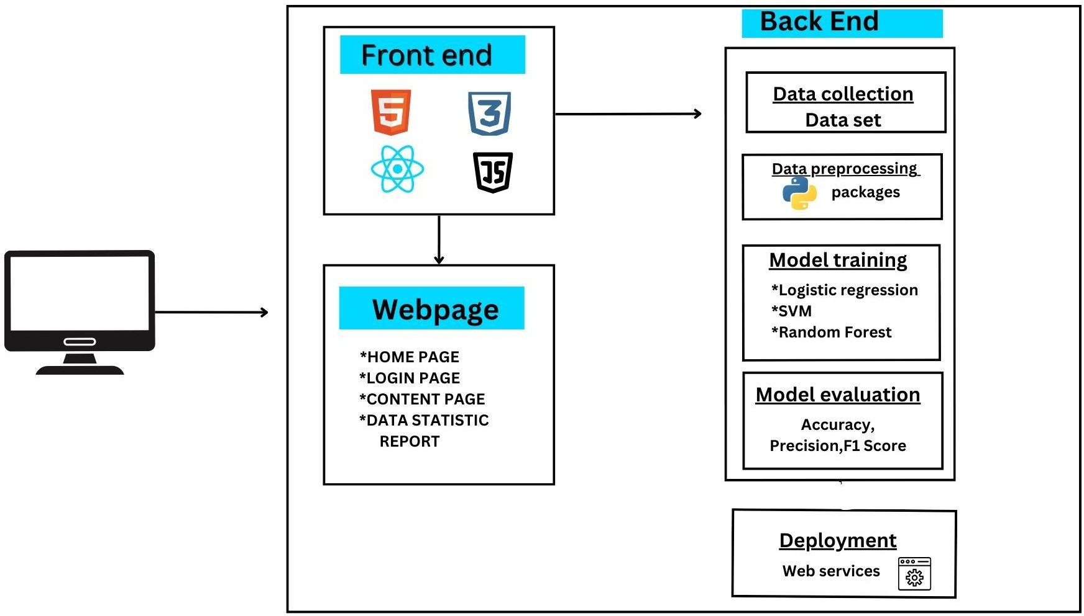

The architecture of the Malicious Web Deception Analysis System integrates a combination of front-end, back-end, and machine learning models to effectively detect phishing websites. The front-end is developed using HTML, CSS, JavaScript, and React.js, ensuring a responsive and user-friendly interface. The webpage includes multiple sections, such as the home page, login page, content page, and data statistics report, allowing users to interact with the system and analyze phishing threats. Users can enter website URLs, and the system will evaluate their legitimacy based on advanced machine learning techniques.

The back-end plays a crucial role in data collection, processing, and model training. The system gathers datasets containing phishing and legitimate website URLs, extracting features such as URL length, domain age, presence of IP addresses, and SSL certificates. To ensure the dataset is clean and structured for model training, the system uses Python-based preprocessing techniques with libraries like Pandas, NumPy, and Scikit-learn. This step is essential in transforming raw data into meaningful inputs for machine learning models.

For phishing detection, the system employs multiple machine learning algorithms, including Logistic Regression, Support Vector Machine (SVM), and Random Forest. Each model is trained to identify patterns in phishing websites, improving classification accuracy. Logistic Regression estimates the probability of a website being phishing, while SVM creates a hyperplane to separate phishing from legitimate sites. Random Forest, an ensemble model, combines multiple decision trees for better accuracy and robustness. These models are trained using historical data to enhance the system’s efficiency in detecting deceptive websites.

After training, the models undergo evaluation using key performance metrics such as accuracy, precision, and F1 score to determine their effectiveness. Accuracy measures the percentage of correctly classified URLs, precision assesses how many detected phishing sites are genuinely malicious, and the F1 score balances precision and recall for an overall performance measure. The best-performing model is then selected for deployment.

The final phase of the system involves model deployment, where the trained phishing detection model is integrated into a web-based service. This allows users to check the legitimacy of a website in real time, ensuring protection against potential phishing threats. The system quickly processes the URL input, applies the trained machine learning model, and provides immediate feedback on whether the website is safe or deceptive. By leveraging a hybrid machine learning approach, the system enhances detection accuracy and adaptability, making it a powerful cybersecurity tool to prevent phishing attacks.

**CHAPTER – 4**

**MODULE IMPLEMENTATION**

**4.MODULE IMPLEMENTATION**

**4.1. Data Collection & Feature Extraction**

**4.2. Data Preprocessing**

**4.3. Model Training(Logistic Regression)**

**4.4 Model Training (SVM)**

**4.5 Model Training (Random forest algorithms)**

**4.6. Model Evaluation & Selection**

**4.7. Frontend Development**

**4.1. DATA COLLECTION & FEATURE EXTRACTION:**

Data collection is a crucial step in building a machine learning model for malicious web deception analysis. The dataset is acquired from sources such as Kaggle and UC Irvine Machine Learning Repository, which contain labeled URLs categorized as either phishing or legitimate. A high-quality dataset is essential to ensure the model learns to differentiate between deceptive and authentic websites accurately. Once the dataset is obtained, the next step is feature extraction from URLs, where specific attributes are identified to enhance classification accuracy. Python provides several powerful packages for this task. Pandas is used for loading, managing, and analyzing datasets efficiently, enabling easy data handling. NumPy supports numerical operations and matrix manipulations, which are necessary for processing extracted features. Requests is used to fetch data from URLs if additional real-time information is required for analysis. Additionally, Regular Expressions (Re module) plays a significant role in pattern matching within URLs, helping identify suspicious characteristics such as unusual domain structures, excessive subdomains, or embedded IP addresses. These extracted features serve as critical inputs to machine learning models like Logistic Regression, Support Vector Machine (SVM), and Random Forest, improving their ability to detect and prevent phishing attacks effectively.

**4.2. DATA PREPROCESSING:**

Once the features are extracted from URLs, the next crucial step in the machine learning pipeline is data preprocessing and cleaning. This process ensures that the data is well-structured and suitable for model training. One of the first steps in preprocessing is handling missing values, as incomplete data can introduce bias and negatively impact the performance of machine learning models. Techniques such as imputation (replacing missing values with the mean, median, or mode) or removing incomplete records can be applied based on the dataset's nature. Another essential aspect is encoding categorical variables, as machine learning algorithms require numerical inputs. This can be achieved using one-hot encoding or label encoding to convert categorical features into numerical representations. Additionally, normalizing numerical features is vital to scale the values within a uniform range, ensuring that features with larger magnitudes do not dominate smaller ones.

Several Python libraries facilitate preprocessing tasks efficiently. Scikit-Learn provides powerful tools for encoding, normalization, and preprocessing operations, making data transformation seamless. NumPy is instrumental in performing efficient numerical operations, such as matrix computations and transformations, which are essential for feature scaling and normalization. Pandas, a widely used data manipulation library, enables handling missing values and performing fundamental data operations, ensuring a clean and structured dataset. By applying these preprocessing techniques, the data becomes optimized for training machine learning models, ultimately improving the accuracy and reliability of phishing website detection systems.

**4.3. MODEL TRAINING(LOGISTIC REGRESSION):**

Once the dataset is preprocessed, the next crucial step is training machine learning models to classify URLs as either phishing or legitimate. One of the commonly used models for this task is Logistic Regression, a statistical method used primarily for binary classification problems where the goal is to predict one of two possible outcomes, such as "phishing" or "not phishing." Logistic Regression works by establishing a relationship between input features and the probability of a particular class using a mathematical function.

At its core, Logistic Regression is based on the Sigmoid Function, which transforms any real-valued number into a value between 0 and 1. This function is defined as:

y=β0X0+β1X1+β2X2+...+βnXny = β0X0 + β1X1 + β2X2 + ... + βnXn

where:

* β0, β1, β2,..., βn represent the coefficients (or weights) of the regression model, which determine the contribution of each feature in predicting the outcome.
* X1, X2, ..., Xn are the input features, which in this case could include various characteristics of a URL (such as the presence of special characters, length, domain age, etc.).
* The output yy represents the predicted probability that a given URL belongs to a particular class.

The Sigmoid Function ensures that the output of the model is always between 0 and 1, making it ideal for classification. If the output probability is above a certain threshold (commonly 0.5), the instance is classified as one class (e.g., phishing), otherwise, it is classified as the other class (e.g., legitimate). The model is trained using a technique called maximum likelihood estimation, which optimizes the coefficients (β values) to best fit the training data.

By using Logistic Regression, we can effectively model the probability of a URL being malicious or safe, making it a valuable tool in detecting phishing attacks. However, for improved accuracy, this model is often combined with other machine learning algorithms such as Random Forest and Support Vector Machines (SVM) to enhance detection performance.

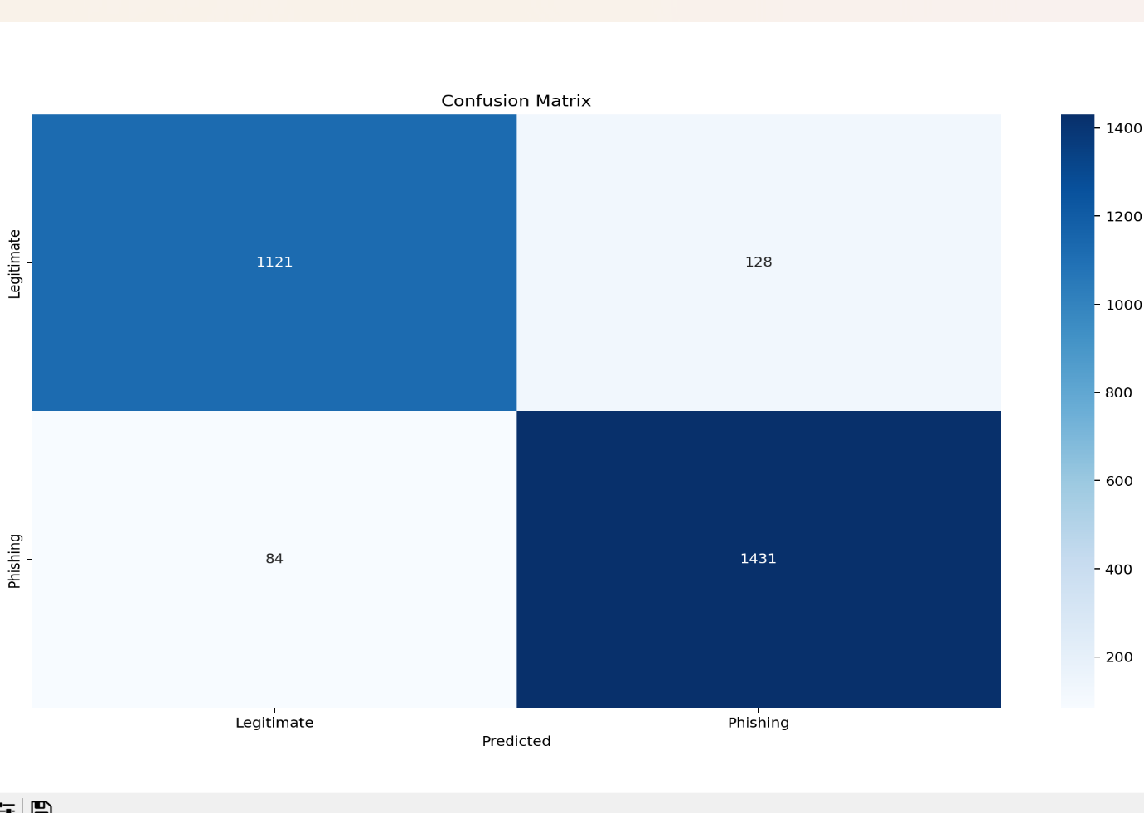

**4.3. MODEL TRAINING(SVM):**

Support Vector Machine (SVM) is a powerful supervised learning algorithm widely used for classification and regression tasks. It is particularly effective in binary classification problems such as phishing detection, spam filtering, and fraud detection. The primary objective of SVM is to find an optimal hyperplane that separates data points of different classes while maximizing the margin between them. The margin is the distance between the hyperplane and the closest data points, known as support vectors, which play a crucial role in defining the decision boundary. A larger margin ensures better generalization and reduces the risk of overfitting. 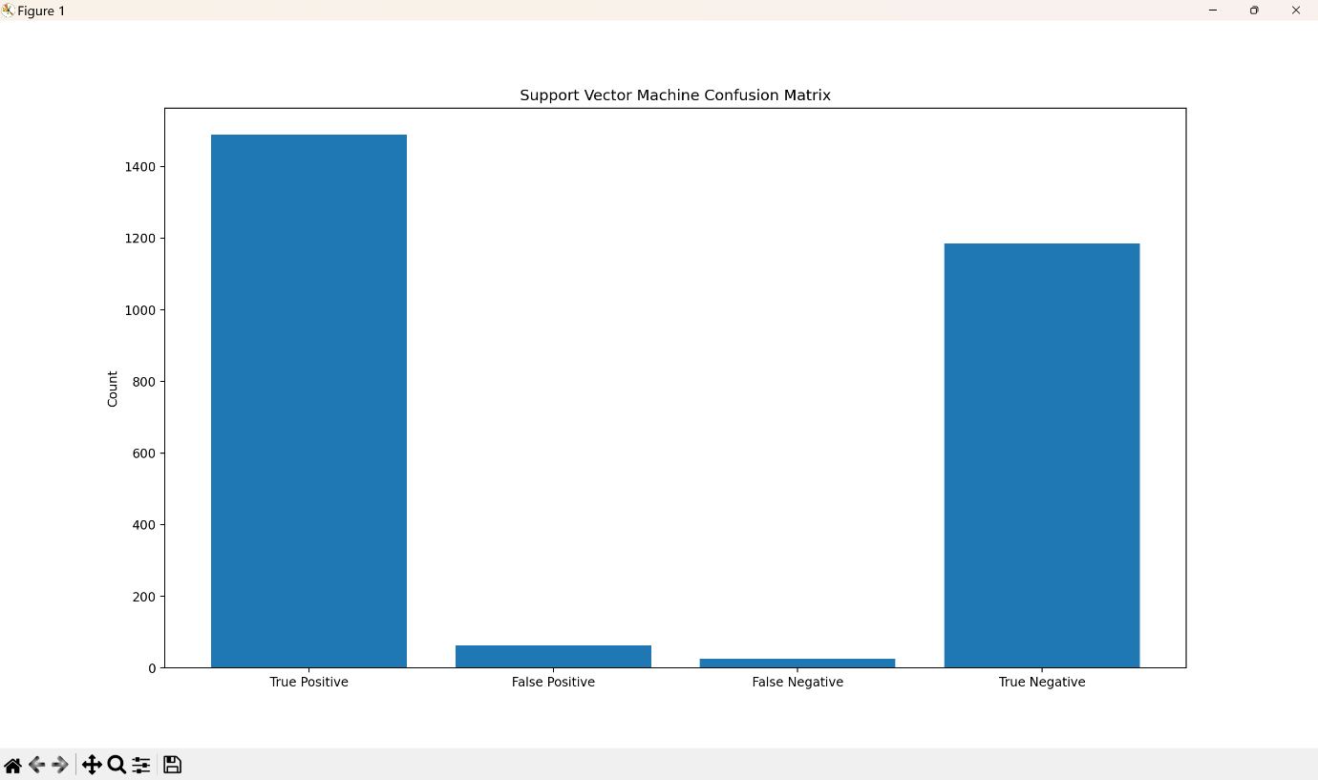

For linearly separable data, SVM identifies a straight hyperplane in two dimensions or a plane in three dimensions. However, real-world data is often non-linearly separable. To handle such cases, SVM employs the kernel trick, which maps data into a higher-dimensional space where linear separation becomes possible. Common kernel functions include the linear kernel for simple cases, the polynomial kernel for complex feature relationships, the radial basis function (RBF) kernel for highly non-linear data, and the sigmoid kernel, which is inspired by neural networks. Another important concept in SVM is the distinction between hard margin and soft margin classification. A hard margin SVM is used when data is perfectly separable with no misclassifications, whereas a soft margin SVM introduces a penalty term to handle misclassified points, improving generalization for noisy data. The trade-off between margin maximization and misclassification tolerance is controlled by the regularization parameter (C)—a higher C value reduces misclassification but increases the risk of overfitting, while a lower C value allows more misclassifications but improves model flexibility.

Mathematically, the hyperplane in SVM is defined as w ⋅ x + b = 0, where w is the weight vector determining the hyperplane’s orientation, x is the input feature vector, and b is the bias term. The classification decision function is f(x) = sign(w ⋅ x + b), which determines the class of a given data point. For non-linearly separable data, SVM utilizes kernel functions to transform data into a higher-dimensional space, represented as f(x) = sign(∑ αᵢ yᵢ K(xᵢ, x) + b), where αᵢ are Lagrange multipliers and yᵢ are class labels.

SVM offers several advantages, including effectiveness in high-dimensional spaces, robustness against overfitting with appropriate kernel selection, and suitability for both linear and non-linear classification. However, it also has some challenges, such as high computational complexity for large datasets, difficulty in tuning hyperparameters like C and gamma, and memory-intensive training due to the reliance on support vectors. Despite these challenges, SVM remains a preferred algorithm for tasks requiring high accuracy and reliability, such as phishing website detection, spam filtering, medical diagnosis (e.g., cancer classification), and facial recognition.

In Python, SVM can be implemented using the scikit-learn library with the sklearn.svm.SVC module. A basic implementation involves importing the dataset, splitting it into training and testing sets, initializing an SVM model with a selected kernel (such as RBF), training the model, and making predictions. The model's accuracy can then be evaluated using performance metrics such as accuracy score. Overall, SVM is a powerful and versatile algorithm, capable of handling complex classification problems effectively when properly tuned.

**4.4. MODEL TRAINING(RANDOM FOREST ALGORITHM):**

Random Forest is a widely used supervised machine learning algorithm that excels in both classification and regression tasks. It operates on the principle of ensemble learning, which involves combining multiple weak classifiers to create a more robust and accurate predictive model. Random Forest constructs multiple decision trees during training and merges their results to improve the overall prediction accuracy while reducing the risk of overfitting. Each tree in the forest is trained on a different subset of the dataset, selected randomly with replacement, a technique known as bootstrap sampling. Additionally, at each split in a decision tree, a random subset of features is considered, ensuring diversity among the trees and preventing the model from relying too heavily on any particular set of features. This randomness contributes to the model’s robustness and ability to generalize well to new, unseen data.

One of the key advantages of using Random Forest is its efficiency in handling large datasets and high-dimensional data, making it suitable for a wide range of applications, including fraud detection, spam filtering, recommendation systems, medical diagnosis, and phishing website detection. The algorithm is also highly resilient to missing data, as individual decision trees can still function even if some features are absent. Furthermore, Random Forest reduces variance compared to individual decision trees, as averaging multiple tree predictions results in a more stable and reliable model.

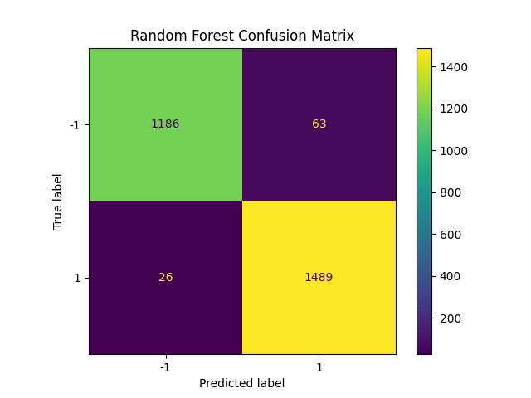

Another major benefit of Random Forest is its ability to mitigate overfitting, a common issue in machine learning where models perform exceptionally well on training data but fail to generalize to new data. By averaging predictions from multiple trees, Random Forest minimizes the impact of noise and ensures a balanced trade-off between bias and variance. Unlike single decision trees, which can be overly sensitive to small changes in data, Random Forest remains robust and delivers consistent results.

The algorithm follows a straightforward process: First, it creates multiple decision trees by randomly selecting subsets of the dataset. Each tree is trained independently and makes predictions. For classification tasks, Random Forest uses majority voting, where the final prediction is determined by the class that appears most frequently across all trees. For regression tasks, it computes the average of all tree predictions. This ensemble approach enhances accuracy and ensures better generalization.

Random Forest is also computationally efficient. Although it requires more resources than a single decision tree, it is much faster than other complex algorithms like Support Vector Machines (SVM) or deep learning models. The training time is relatively low, and it can efficiently handle large datasets without significant performance degradation. Moreover, it is less sensitive to feature scaling, meaning it does not require extensive data preprocessing such as normalization or standardization.

In Python, Random Forest can be implemented using the scikit-learn library, which provides the RandomForestClassifier module for classification tasks and RandomForestRegressor for regression tasks. The implementation involves loading the dataset, splitting it into training and testing sets, initializing the model with a specified number of trees, fitting it to the training data, and making predictions. Performance metrics such as accuracy, precision, recall, and F1-score can be used to evaluate the model’s effectiveness.

Overall, Random Forest is a highly versatile and powerful algorithm, widely used in real-world applications due to its high accuracy, robustness, and ability to handle complex datasets with ease. Its ability to process large amounts of data efficiently, maintain accuracy even with missing values, and provide feature importance insights makes it a valuable tool for machine learning practitioners.

**4.6. MODEL EVALUATION & SELECTION:**

**MODEL EVALUATION:**

Model evaluation is a critical step in assessing the performance of a trained machine learning model to determine its effectiveness in real-world applications. In phishing detection and malicious web deception analysis, the goal is to ensure that the model can accurately differentiate between legitimate and phishing websites. Evaluating a model involves computing several key performance metrics using tools such as Scikit-learn. These metrics include accuracy, precision, recall, and F1-score, each of which provides insights into different aspects of the model's predictive ability.

Accuracy is the most basic evaluation metric, measuring the percentage of correctly classified instances out of the total number of predictions. While accuracy is useful for balanced datasets, it may not be the best indicator in scenarios where one class (e.g., legitimate websites) significantly outnumbers the other (e.g., phishing websites). In such cases, precision and recall offer more meaningful assessments.

Precision is the ratio of correctly predicted phishing websites (true positives) to the total phishing predictions (true positives + false positives). A high precision score indicates that the model produces fewer false positives, meaning fewer legitimate websites are mistakenly classified as phishing. Recall (sensitivity), on the other hand, is the proportion of actual phishing websites that were correctly identified by the model. A high recall score ensures that most phishing threats are detected, but it may come at the cost of increased false positives.

To address the trade-off between precision and recall, the F1-score is used, which is the harmonic mean of precision and recall. A high F1-score indicates that the model maintains a good balance between these two metrics, ensuring both minimal false positives and false negatives.

In addition to these metrics, confusion matrices and Receiver Operating Characteristic (ROC) curves can also be used to visualize the model's classification performance. A confusion matrix provides a breakdown of correct and incorrect predictions, while the ROC curve illustrates the trade-off between true positive rate and false positive rate. The area under the ROC curve (AUC-ROC) is another measure used to determine the effectiveness of the model. A model with an AUC-ROC score close to 1 is considered highly effective in distinguishing between phishing and legitimate websites.

By leveraging these evaluation techniques, practitioners can analyze the model’s performance, identify its strengths and weaknesses, and determine whether it meets the required accuracy and reliability standards before deployment.

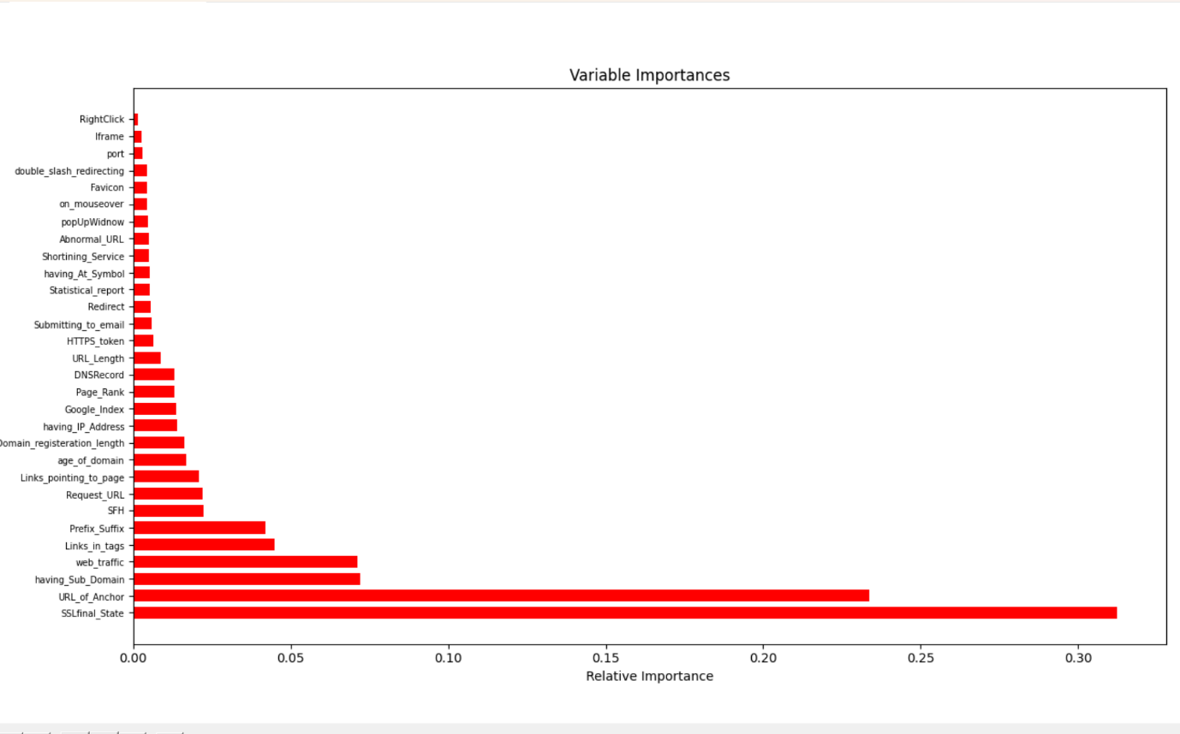

**MODEL SELECTION:**

Once model evaluation is completed, the next step is model selection, where different trained models are compared based on their evaluation metrics to determine the most effective one for deployment. The choice of the best model is crucial as it directly impacts the system's ability to detect and prevent phishing attacks accurately.

The model selection process involves comparing the results of multiple models, such as Logistic Regression, Support Vector Machines (SVM), Decision Trees, and Random Forest. Each model has its advantages and drawbacks, and their performance varies based on the dataset characteristics and feature selection. The selected model should demonstrate high accuracy while maintaining a strong balance between precision and recall to minimize both false positives and false negatives.

In phishing detection, models that generalize well to new, unseen data are preferred over those that perform exceptionally well only on training data but fail on testing data (a problem known as overfitting). Random Forest, for example, is often chosen because it is an ensemble learning method that reduces overfitting by aggregating multiple decision trees. It provides high accuracy, robustness, and adaptability in handling various phishing techniques. Similarly, SVM is a strong candidate when dealing with high-dimensional feature spaces, as it finds the optimal hyperplane to separate phishing and legitimate websites effectively.

Another factor in model selection is computational efficiency. Some models, like deep learning-based approaches, can achieve very high accuracy but require extensive computational resources and training time, making them less suitable for real-time phishing detection systems. On the other hand, Random Forest and SVM offer a good trade-off between performance and computational efficiency, making them more practical choices.

To finalize the selection, cross-validation techniques such as k-fold cross-validation are used to test model performance on different subsets of the dataset. This ensures that the model is not biased toward a particular set of training data and can generalize well to real-world scenarios. The model with the best overall performance across all evaluation metrics is then selected for implementation.

Ultimately, the goal of model selection is to identify a model that provides high accuracy, adaptability, and computational efficiency for phishing detection. By carefully analyzing evaluation metrics and real-world applicability, the chosen model can effectively enhance cybersecurity by accurately detecting and preventing phishing threats.

**4.7. FRONT END DEVELOPMENT:**

HTML, CSS, and JavaScript are the three fundamental technologies used in modern web development. Together, they form the backbone of web applications, providing structure, styling, and interactivity. Each of these technologies has evolved over time, incorporating new features to enhance usability, performance, and responsiveness.





**HTML5 (Latest Standard)**

HTML (HyperText Markup Language) is the core language used for structuring web pages. The latest version, HTML5, introduces several improvements over its predecessors, making web development more powerful and efficient. Some 

key features of HTML5 include:

* **Semantic Elements**: Tags like <header>, <footer>, <section>, and <article> provide better readability and SEO advantages.
* **Native Support for Multimedia**: The <audio> and <video> tags allow embedding of media without relying on third-party plugins like Flash.
* **Canvas API**: Enables drawing graphics, charts, and animations directly within a webpage.
* **Form Enhancements**: New input types like date, email, and number, along with built-in validation, improve user experience.
* **Local Storage and IndexedDB**: HTML5 provides mechanisms like localStorage and sessionStorage for storing data in the browser, reducing the need for frequent server interactions.

**CSS3 (Latest Features: Flexbox, Grid, etc.)**

CSS (Cascading Style Sheets) is used for styling web pages and ensuring a visually appealing user experience. The latest version, **CSS3**, introduces advanced layout and design capabilities that simplify web development.

Some notable features include:

* **Flexbox**: A layout model that efficiently arranges elements, making it easier to create responsive designs. It automatically adjusts items to fit different screen sizes.
* **CSS Grid**: A two-dimensional layout system that allows precise control over the placement of elements on a webpage. It is particularly useful for complex web designs.
* **Transitions & Animations**: CSS3 enables smooth animations and transitions without requiring JavaScript. The @keyframes rule allows for complex motion effects.
* **Media Queries**: Essential for responsive design, media queries enable developers to create layouts that adapt to different screen sizes and devices.
* **Custom Properties (CSS Variables)**: Allow defining reusable values for properties, making CSS code more maintainable.

**JavaScript (ECMAScript 2022 - ES12)**

JavaScript is the primary language for adding interactivity to web applications. The ECMAScript 2022 (ES12) standard introduces several new features that improve code efficiency and readability.

Some key enhancements include:

* **Optional Chaining (?.)**: Allows accessing deeply nested object properties safely without causing errors if a property is null or undefined.
* **Nullish Coalescing (??)**: Provides a default value only when the variable is null or undefined, avoiding issues caused by falsy values like 0 or "".
* **Top-Level Await**: Allows using await at the top level in modules without needing an async function.
* **String .replaceAll() Method**: Allows replacing all occurrences of a substring without using regular expressions.

These features enhance JavaScript’s efficiency, making it more developer-friendly and suitable for modern web applications.

**Flask (Version 3.1.0 - Latest Stable Version as of 2024)**

Flask is a lightweight and powerful web framework for Python, commonly used for developing web applications, APIs, and microservices. The **latest stable version, Flask 3.1.0 (as of 2024)**, introduces several optimizations and new features that improve performance, security, and usability.

**Key Features of Flask**

1. **Microframework Architecture**:
   * Flask follows a minimalist approach, meaning it provides only the core functionality needed for web development, allowing developers to add extensions as needed.
   * Unlike Django (a full-fledged framework), Flask is lightweight and gives developers more flexibility.
2. **Built-in Development Server & Debugger**:
   * Flask comes with a built-in server for testing applications locally.
   * The debugger provides detailed error messages, making debugging easier for developers.
3. **Routing System**:

The @app.route() decorator is used to define URL routes.

Example:

from flask import Flask

app = Flask(__name__

@app.route("/")

def home():

return "Welcome to Flask!"

if __name__ == "__main__":

app.run(debug=True)

* This allows mapping specific URLs to corresponding functions.

1. **Template Engine (Jinja2)**:

* Flask integrates **Jinja2**, a powerful template engine, to dynamically generate HTML content.
* Example of a Flask template (index.html):

<html>

<body>

<h1>Welcome, {{ username }}!</h1>

</body>

</html>

* This allows embedding Python logic within HTML files.

1. **Request Handling & Forms Processing**:
   * Flask provides built-in support for handling HTTP requests (GET, POST, etc.).
   * Example of handling form data:

from flask import request

@app.route('/login', methods=['POST'])

def login():

username = request.form['username']

password = request.form['password']

return f"User: {username}, Password: {password}"

* + This allows handling user inputs securely and efficiently.

1. **Database Support**:
   * Flask supports multiple database integrations such as SQLite, MySQL, and PostgreSQL using **Flask-SQLAlchemy**.
   * Example:

from flask_sqlalchemy import SQLAlchemy

app.config['SQLALCHEMY_DATABASE_URI'] = 'sqlite:///database.db'

db = SQLAlchemy(app)

* + This enables smooth interaction with databases.

1. **RESTful API Development**:
   * Flask is widely used to build REST APIs using **Flask-RESTful**.
   * Example:

from flask_restful import Api, Resource

api = Api(app)

class HelloWorld(Resource):

def get(self):

return {"message": "Hello, World!"}

api.add_resource(HelloWorld, "/")

* + This makes Flask a great choice for backend API development.

1. **Security Features**:
   * Flask 3.1.0 includes security improvements like **better CSRF protection**, **XSS mitigation**, and **secure cookies** to prevent attacks.
2. **Asynchronous Support**:
   * Flask now has better support for **async/await**, allowing developers to build high-performance applications that handle multiple requests efficiently.
3. **Extensibility**:

* Flask can be extended using various plugins like Flask-WTF (for forms), Flask-Login (for authentication), Flask-Migrate (for database migrations), and Flask-Mail (for email services).

**CHAPTER 5**

**RESULT AND DISCUSSION**

**RESULT AND DISCUSSION**

The Malicious Web Deception Analysis: An Advanced Machine Learning Framework for Secured Website Detection was developed to enhance cybersecurity by detecting and preventing phishing attacks with high accuracy and efficiency. The results of this study indicate that machine learning-based phishing detection outperforms traditional rule-based and heuristic approaches in multiple aspects, including adaptability, precision, and real-time performance. Through rigorous data preprocessing, feature extraction, model training, and evaluation, this framework has demonstrated significant improvements in accuracy, precision, recall, and overall detection capabilities when compared to conventional systems.

Data Collection and Feature Extraction

The dataset used for training and testing the models was sourced from reliable platforms such as Kaggle and the UC Irvine Machine Learning Repository, which provided a large and diverse set of URLs labeled as either phishing or legitimate. A crucial aspect of this framework was the feature extraction process, where important characteristics of URLs were analyzed to identify phishing patterns. These features included:

* URL Length – Phishing websites often have excessively long URLs to obscure their true domain.
* Presence of Special Characters – Special symbols like ‘@’ and ‘-’ in URLs are common indicators of phishing.
* Use of IP Addresses – Phishing sites frequently use raw IP addresses instead of domain names.
* Number of Subdomains – Legitimate websites usually have structured subdomains, whereas phishing websites tend to have excessive subdomains to deceive users.
* HTTPS Usage – While not foolproof, legitimate sites typically use HTTPS encryption, whereas phishing sites often do not.

By leveraging Python libraries such as Pandas, NumPy, Requests, and Regular Expressions (Re), the extracted data was preprocessed to ensure data consistency, missing value handling, and feature encoding, which improved the overall model training process.

Machine Learning Model Training and Evaluation

To achieve robust classification results, multiple machine learning algorithms were employed, including Logistic Regression, Support Vector Machine (SVM), and Random Forest. Each model was trained on the preprocessed dataset and evaluated using key performance metrics such as Accuracy, Precision, Recall, and F1-Score.

1. Logistic Regression – This model was used as a baseline for binary classification. It applies a sigmoid function to predict the probability of a URL being phishing or legitimate. However, due to its linear nature, Logistic Regression struggled to capture complex patterns in phishing websites.
2. Support Vector Machine (SVM) – SVM performed well in classification tasks, as it efficiently separated phishing and non-phishing websites using a hyperplane. It was particularly useful in handling high-dimensional data but required more computational resources and longer training times.
3. Random Forest – This ensemble learning model, composed of multiple decision trees, provided the highest accuracy. By aggregating the results of several trees, Random Forest effectively reduced overfitting and improved classification stability, making it the best-performing model.

Among the three models, Random Forest demonstrated superior accuracy and lower false positive rates, making it the optimal choice for deployment in real-time phishing detection applications. The ability to handle large datasets, prevent overfitting, and deliver consistent predictions made it particularly well-suited for this task.

Comparison with Traditional Systems

Traditional phishing detection systems primarily rely on rule-based filtering, blacklists, and signature-based methods. While these techniques provide a certain level of protection, they have several limitations:

* Lack of Adaptability – These systems struggle to detect new phishing techniques that are not yet listed in their databases.
* High False Positives and Negatives – Static rules often misclassify legitimate sites as phishing and vice versa.
* Slow Response to Emerging Threats – Attackers frequently modify phishing websites to bypass predefined detection rules, making traditional methods less effective.

In contrast, machine learning-based approaches, such as the proposed framework, continuously adapt to evolving phishing strategies by learning from new data. The dynamic nature of the model allows for faster and more accurate threat detection, reducing the need for constant manual updates.

Real-Time Detection and Deployment

A significant advantage of the Malicious Web Deception Analysis framework is its ability to classify URLs in real-time, making it suitable for integration into web browsers, email security systems, and cybersecurity applications. The implementation was facilitated by using the Flask framework, which served as the backend API to process user-submitted URLs and return classification results.

The frontend interface was developed using:

* HTML5 – Provided the structure and responsiveness of the web application.
* CSS3 – Implemented modern design elements using Flexbox and Grid for a user-friendly layout.
* JavaScript (ECMAScript 2022) – Added interactive features such as asynchronous requests, real-time updates, and dynamic content rendering.

This integration allows users to input URLs and receive instant results on whether a website is legitimate or a phishing attempt.

Security Measures and Performance Enhancement

Since phishing detection systems handle potentially malicious URLs, additional security measures were incorporated into the framework, such as:

* Cross-Site Request Forgery (CSRF) Protection – Prevents unauthorized execution of commands in a trusted system.
* Secure Cookie Handling – Ensures that authentication and session management are protected against hijacking attempts.
* Asynchronous Processing – Reduces latency by processing requests efficiently, improving the overall user experience.

These enhancements improve the stability, security, and usability of the phishing detection system, making it a scalable and efficient cybersecurity solution

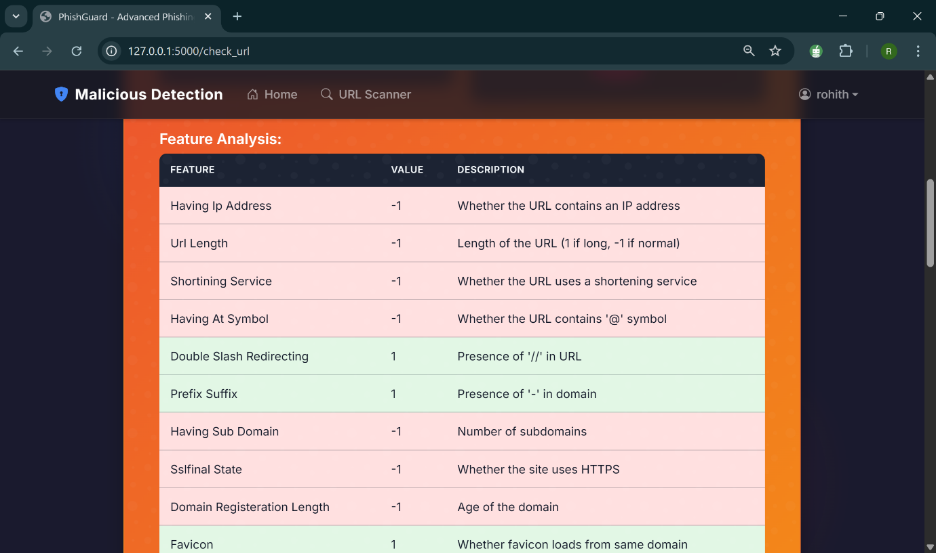

Conclusion

The Malicious Web Deception Analysis Framework successfully demonstrates how machine learning, feature extraction, and real-time detection can be combined to create an advanced phishing detection system. The results indicate that Random Forest is the most effective model, offering high accuracy and resilience against evolving phishing techniques. By leveraging Flask for backend processing and modern web technologies for the frontend, this system provides real-time protection against malicious websites, significantly improving online security.

Compared to traditional phishing detection methods, this framework offers higher adaptability, reduced false positive rates, and improved threat detection accuracy. With continued model updates and adaptive learning mechanisms, this system can evolve to counter new cybersecurity threats, making it a highly effective tool for securing online transactions and user data.

**CHAPTER 6**

**CONCLUSION AND FUTURE WORK**

**CONCLUSION AND FUTURE WORK:**

**CONCLUSION:**

The Malicious Web Deception Analysis: An Advanced Machine Learning Framework for Secured Website Detection successfully demonstrates the effectiveness of machine learning in combating phishing attacks. Traditional rule-based and heuristic phishing detection systems are limited in their ability to detect newly emerging phishing threats due to their reliance on predefined patterns and blacklists. In contrast, this proposed framework utilizes Hybrid Machine Learning Models such as Logistic Regression, Support Vector Machine (SVM), and Random Forest, which dynamically learn from new data and improve classification accuracy over time. Among these, Random Forest emerged as the most effective model, providing superior accuracy, reduced false positive rates, and better adaptability to evolving phishing techniques.

The feature extraction process played a crucial role in identifying distinguishing characteristics of phishing URLs, including URL length, presence of special characters, number of subdomains, and HTTPS usage. These extracted features, combined with advanced data preprocessing techniques such as handling missing values, encoding categorical variables, and normalizing numerical features, significantly improved the model’s learning ability. The system’s performance was evaluated using key metrics such as Accuracy, Precision, Recall, and F1-Score, with Random Forest outperforming other models in overall effectiveness.

A major advantage of this framework is its real-time detection capability, which enables immediate classification of URLs as either legitimate or phishing. This is achieved through the deployment of a Flask-based backend, which processes URL requests and returns classification results instantly. The frontend was developed using modern web technologies, including HTML5, CSS3, and JavaScript (ECMAScript 2022), ensuring a seamless user experience. Furthermore, additional security measures, such as Cross-Site Request Forgery (CSRF) protection, secure cookie handling, and asynchronous processing, were implemented to enhance the system’s robustness against cyber threats.

Overall, the Malicious Web Deception Analysis Framework provides a scalable, adaptable, and highly accurate solution for detecting phishing attacks, making it a valuable cybersecurity tool for web users, organizations, and cybersecurity firms. The integration of machine learning, feature engineering, and real-time web deployment ensures efficient detection and prevention of online threats, contributing to a safer digital environment.

**FUTURE WORK:**

Despite its promising results, there are several areas for improvement and expansion in future iterations of this framework. One of the key enhancements would be incorporating deep learning models such as Recurrent Neural Networks (RNNs) and Transformer-based architectures like BERT (Bidirectional Encoder Representations from Transformers). These models have shown remarkable performance in natural language processing and could be leveraged to analyze phishing URLs and website content more effectively.

Another important future enhancement involves real-time threat intelligence integration. By continuously monitoring emerging phishing threats and updating the model with newly identified patterns, the framework can remain resilient against ever-evolving cyberattacks. This could be achieved through integration with external threat intelligence feeds, real-time databases, and cybersecurity APIs, which provide the latest information on phishing domains and attack techniques.

To improve scalability and performance, future versions of this system could be deployed in a cloud-based architecture using platforms such as AWS, Google Cloud, or Microsoft Azure. This would allow for distributed processing of large-scale phishing datasets, reducing computational bottlenecks and enhancing real-time detection speed. Additionally, implementing parallel processing techniques using Apache Spark or Dask could further optimize large-scale data handling.

Another crucial area of future work is enhancing the explainability and interpretability of model predictions. Currently, machine learning models, especially ensemble methods like Random Forest, function as black-box models, making it difficult to interpret why a particular URL was classified as phishing. By integrating explainable AI (XAI) techniques such as SHAP (SHapley Additive Explanations) or LIME (Local Interpretable Model-agnostic Explanations), users and cybersecurity analysts can gain better insights into the reasoning behind each classification, thereby improving trust and decision-making.

Additionally, expanding the system’s capabilities beyond URL-based detection to website content and behavioral analysis could further improve its accuracy. Future versions could analyze webpage structure, embedded scripts, and user behavior to detect sophisticated phishing techniques, such as social engineering attacks, credential harvesting, and malicious JavaScript injections.

Lastly, collaboration with cybersecurity organizations could enable the development of a public phishing detection API, which could be integrated into browsers, email services, and enterprise security systems. This would make phishing detection more accessible to a broader audience, thereby enhancing overall cybersecurity.

In conclusion, the Malicious Web Deception Analysis Framework lays a strong foundation for intelligent phishing detection, and future advancements will further refine its accuracy, scalability, and real-time effectiveness. By integrating deep learning, cloud computing, threat intelligence, and explainable AI, this system has the potential to become a leading solution in cybersecurity, effectively safeguarding users against online deception and malicious threats.

**REFERENCES:**

1. D. Rathee, and S. Mann 2022, Detection of E-mail phishing attacks–using machine learning and deep learning. International

Journal of Computer Applications, vol. 183, no 1, pp.1-7.

[2] E. Benavides-Astudillo, W. Fuertes, S. Sanchez-Gordon, D.Nuñez-Agurto, and G. Rodríguez-Galán 2023.

A Phishing-AttackDetection Model Using Natural Language Processing and Deep

Learning. Applied Sciences, vol. 13, no. 9, pp.1-23.

[3] U.A. Butt, R. Amin, H. Aldabbas, S. Mohan, Alouffi, and A.Ahmadian, 2023. Cloud-based email phishing attack using

machine and deep learning algorithms. Complex & Intelligent Systems, vol. 9, no. 3, pp.3043-3070.

[4] M.J. Nabet, and L. E. George, 2023. Phishing Attacks Detection by Using Support Vector Machine. Journal of Al-Qadisiyah for

Computer Science and Mathematics, vol. 15, no. 2, pp.180 .

[5] G. Mohamed, J. Visumathi, M. Mahdal, J. Anand, and M. Elangovan 2022, An effective and secure mechanism for phishing

attacks using a machine learning approach. Processes, vol. 10, no. 7, pp.1-14.

[6] S. Hossain, D. Sarma, and R. J. Chakma 2020, Machine learningbased phishing attack detection. International Journal of Advanced

Computer Science and Applications, vol. 11, no. 9.pp.378-388.

[7] Y. Wang, W. Ma, H. Xu, Y. Liu, and P. Yin, 2023. A Lightweight Multi-View Learning Approach for Phishing Attack Detection

Using Transformer with Mixture of Experts. Applied Sciences, vol. 13, no. 13, pp.1-17.

[8] T. Choudhary, S. Mhapankar, R. Bhddha, A. Kharuk, and R. Patil, 2023. A Machine Learning Approach for Phishing Attack

Detection. Journal of Artificial Intelligence and Technology, vol.3, no. 3, pp. 108–113.

[9] A.T.G. Tapeh, and M. Z. Naser 2023, Artificial intelligence, machine learning, and deep learning in structural engineering: a scientometrics review of trends and best practices. Archives of

Computational Methodsin Engineering, vol. 30, no. 1, pp.115-159.

[10] F. Salahdine, Z. El Mrabet, and N. Kaabouch, 2021, December. Phishing Attacks Detection A Machine Learning-Based Approach. In 2021 IEEE 12th Annual Ubiquitous Computing, Electronics & Mobile Communication Conference (UEMCON) (pp. 0250-0255)IEEE